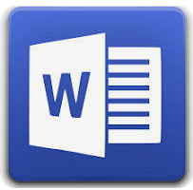

Microsoft Word is a word processing program developed by Microsoft. It was first released on October 25, 1983, under the name Multi-Tool Word for Xenix systems. Subsequent versions were later written for several other platforms including: IBM PCs running DOS (1983), Apple Macintosh running the Classic Mac OS (1985), AT&T UNIX PC (1985), Atari ST (1988), OS/2 (1989), Microsoft Windows (1989), SCO Unix (1990), Handheld PC (1996), Pocket PC (2000), macOS (2001), Web browsers (2010), iOS (2014), and Android (2015).